**Assignment No.2**

**File Handling Commands in UNIX**

**In UNIX there are three basic types of files,**

1. **ORDINARY FILES − An ordinary file is a file on the system that contains data, text, or program instructions. In this tutorial, you look at working with ordinary files.**
2. **DIRECTORIES − Directories store both special and ordinary files. For users familiar with Windows or Mac OS, UNIX directories are equivalent to folders.**
3. **SPECIAL (DEVICE) FILES − Some special files provide access to hardware such as hard drives, CD-ROM drives, modems, and Ethernet adapters. Other special files are similar to aliases or shortcuts and enable you to access a single file using different names.**

**THE PARENT-CHILD RELATIONSHIP:**

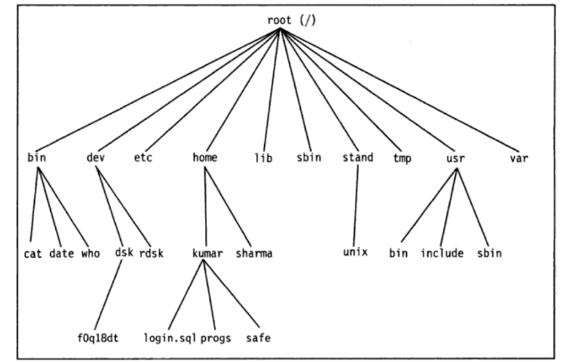

***FIGURE 4.1 UNIX file system***

* **pwd**

**Use to know current working directory.**



* **cd**

**Use to change the current directory**

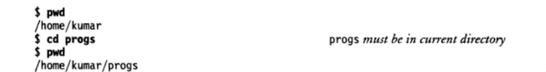

**To Move Upward Directory, use cd .. or cd\**

* **mkdir**

**Use to create directories.**







* **rmdir**

**Use to remove directories**





* **ls**

**Give a list of all filenames in the current directory**

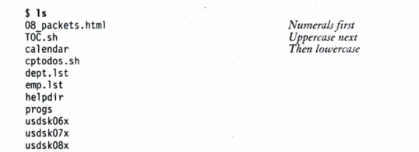

**Options withls**

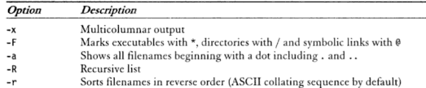

* **cat**

**Used to create a file and also used to open file content**

**Example:**

1. ***$cat>file1 to create file1***
2. ***$cat file1 to view content of file1***

* **cp**

**Used to copying files**

**Example:**

***cp chap01 unit1***

***cp chap01 progs/unit1***

***cp chap01 chap02 chap03 progs multiple file copuing into progs directory***

***cp chap* progs copies all file beginning with chap***

***cp –i chap01 unit1 interactive copying***

***cp –R progs newprogs directory copying with files***

* **rm**

**Used to delete one or more files.**

**Example:**

***rm chap01***

***rm chap01 chap02 chap03 multiple file deletion***

***rm progs/chap01 progs/chap02***

***rm * remove all files***

* **mv**

**it renames or moves files.**

**Example:**

***mv chap01 man01***

***mv chap01 chap02 chap03 progs multiple files moved to progs directory***

***mv progs newprogs rename a directory***

* **file**

**Used to determine the type of file**

**Syntax:**

***$file [filename]***

**Example:**



* **wc**

**Counts lines, words and characters**

**Example:**

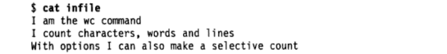



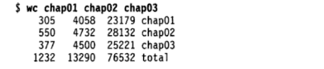

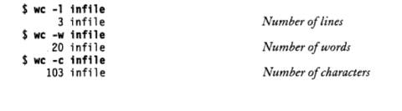

* **od**

**Displays octal data**

**Example:**



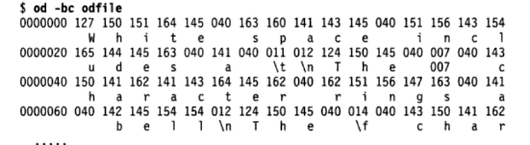

* **cmp**

**Used to compare to files and gives position of first mismatch as a result**

**Example:**



* **comm**

**Find common between two files.**

**Example:**

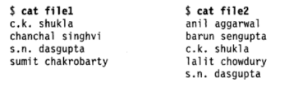

***$commfile1 file2***

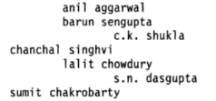

* **diff**

**Used to display file differences and also tells which lines in one file have to be changed to make the two files identical**

**Example:**



